PRACTICE NEWS
Practice Telephone System – Appointment Call Back functionality
This has again been upgraded and if you are phoning for an appointment and there is a long queue, to save you hanging on you will be offered the choice to be called back by a staff member as soon as practicable.
Covid - Spring Booster
If you are eligible for the Covid Spring Booster this is available until the end of June. If you have not had your booster, it can still be obtained by contacting Leek Health Centre on 01538 381022 or available from Leek Pharmacy, Fountain Street Pharmacy and Moorlands Pharmacy who are offering vaccination.
Friends & Family
The NHS still use the figures from the patients compiling the Friends and Family slips as one of the means of assessing Practices and so we would ask you to complete this form after your appointment to maintain the flow of information about our Practice to the NHS. _______________________________________
Missed Appointments with Clinicians (Did Not Attend)
The Practice has detailed analysis of the number of missed appointments by patients and although not massive (2.9% i.e.80 of the 2722 appointments in May) it means that those 80 appointments are lost to other patients.
One of the main concerns is the number of Practice Nurse appointment’s which can be up to 30 minutes and failing to cancel appointment can affect their ability to help other patients.
If you are unable to keep your appointment, please let us know. If you telephone the Practice on 01538 399008 you can cancel your appointment by pressing option 2 and leave a message or you can use the NHS App.

Dr Fraser Currie announced as a Prostate Cancer UK Clinical Champion!
Congratulations to Fraser on his appointment!
Moorland Medical Centre is thrilled to announce Dr Fraser Currie’s success as one of Prostate Cancer UK's new Clinical Champions. Fraser,GP Registrar in his final year, has joined the newest cohort of the Clinical Champions Programme, the flagship improvement programme run by Prostate Cancer UK.
The Clinical Champions Programme is an 18-month programme where clinicians drive projects to improve prostate cancer care within their organisation and local area. Each Champion builds a transformational skillset, equipping them to spearhead long-term improvement for men and their families. As part of this programme, Fraser will increase prostate cancer awareness in the farming and agricultural community whilst networking with clinicians from around the country and building her leadership skills.
Director of Support and Influencing at Prostate Cancer UK, Chiara De Biase wrote:
“We are excited to welcome Fraser Currie to the new cohort of clinicians to our Clinical Champions Programme. This ever-growing community has transformed the pathway for men across the UK, and we’re proud to have recruited such motivated, passionate Champions to drive real-world change. We’re looking forward to seeing the work they’ll be undertaking to improve prostate cancer care over the next 18 months and beyond.”
The impact of the Clinical Champions Programme on prostate cancer care has been nationally recognised by the Health Service Journal, winning Bronze at the recent Partnership Awards.
Prostate Cancer UK would like to congratulate Fraser on his appointment.
Online Consult
Don’t forget you can contact your surgery online
Simply fill in a health enquiry form by clicking on this link found on the practice website or Facebook page https://www.online-consult.co.uk/org/moorland-medical-centre

PATIENT PARTICIPATION GROUP

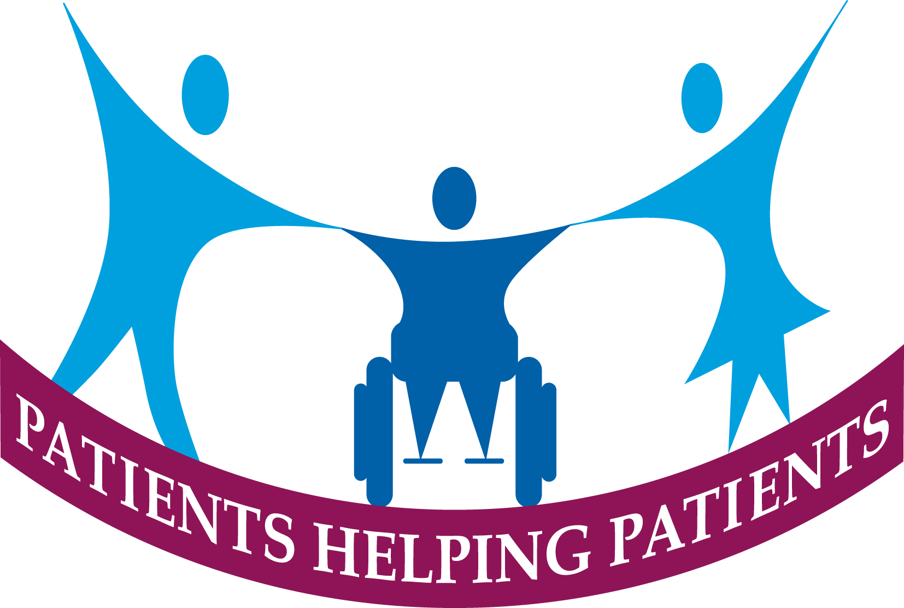

Patient Participation Group Activities
The Patient Participation Group (PPG) continues to meet regularly and currently we are exploring several issues to help patients.
PPG Network across Staffordshire and Stoke on Trent, this is being initiated by the Integrated Care Board to provide a patient voice on Health and Social Care across the County. The inaugural meeting took place on 8th May 2024 and our PPG will be represented along with representatives from the other Practices in the Primary Care Network for Leek & Biddulph.
We are evaluating the Digital support from the Digital Angels (MFPT) to develop joint workshops to help our patients seeking to use the NHS App and Patient Access enabling more patients to order medication, book appointments and access their medical records online.
We have been supporting Leek Health Centre with volunteers for the Covid Spring Booster Clinics.
We continue to be active members of the Leek & Biddulph Patient Locality Group and are working with the Primary Care Network team on a Patient Survey which can include a small number of specific practice questions. This will compliment the practice patient survey that we are conducting over the summertime.
We are always keen to recruit new members so if you are interested, please call into Reception, or go onto the surgery website www.moorlandmedical.co.uk for an Expression of Interest form. Your expression of interest can be emailed to moorland.med@nhs.net.
What’s on Locally Information for you.
Ask at reception for a copy of our local activities information or access the document on our website at www.moorlandmedicalcentre.co.uk

PRESCRIPTION CHANGES

